

SENECA COLLEGE NEWNHAM CAMPUS

COURSE WEB422 SUMMER 2024

ASSIGNMENT2

1. Create the dependencies using bootstrap
2. Create UI Element, using bootstrap to create a Navbar that has a search bar
3. The data that will be used is from this <https://fakestoreapi.com/products>

{

"id": 1,

"title": "Fjallraven - Foldsack No. 1 Backpack, Fits 15 Laptops",

"price": 109.95,

"description": "Your perfect pack for everyday use and walks in the forest. Stash your laptop (up to 15 inches) in the padded sleeve, your everyday",

"category": "men's clothing",

"image": "https://fakestoreapi.com/img/81fPKd-2AYL._AC_SL1500_.jpg",

"rating": {

"rate": 3.9,

"count": 120

}

},

{

"id": 2,

"title": "Mens Casual Premium Slim Fit T-Shirts ",

"price": 22.3,

"description": "Slim-fitting style, contrast raglan long sleeve, three-button henley placket, light weight & soft fabric for breathable and comfortable wearing. And Solid stitched shirts with round neck made for durability and a great fit for casual fashion wear and diehard baseball fans. The Henley style round neckline includes a three-button placket.",

"category": "men's clothing",

"image": "https://fakestoreapi.com/img/71-3HjGNDUL._AC_SY879._SX._UX._SY._UY_.jpg",

"rating": {

"rate": 4.1,

"count": "259"

}

},

1. Create a Main Container & Data Table to display the data in a table format. This will display all "products" by including their userId, title, price, description, image, category and body attributes.
2. Create a JavaScript function  or write a function that will actually pull the data from the API to the table. This will be done using ["fetch()"](https://developer.mozilla.org/en-US/docs/Web/API/Fetch_API), in it's simplest form,

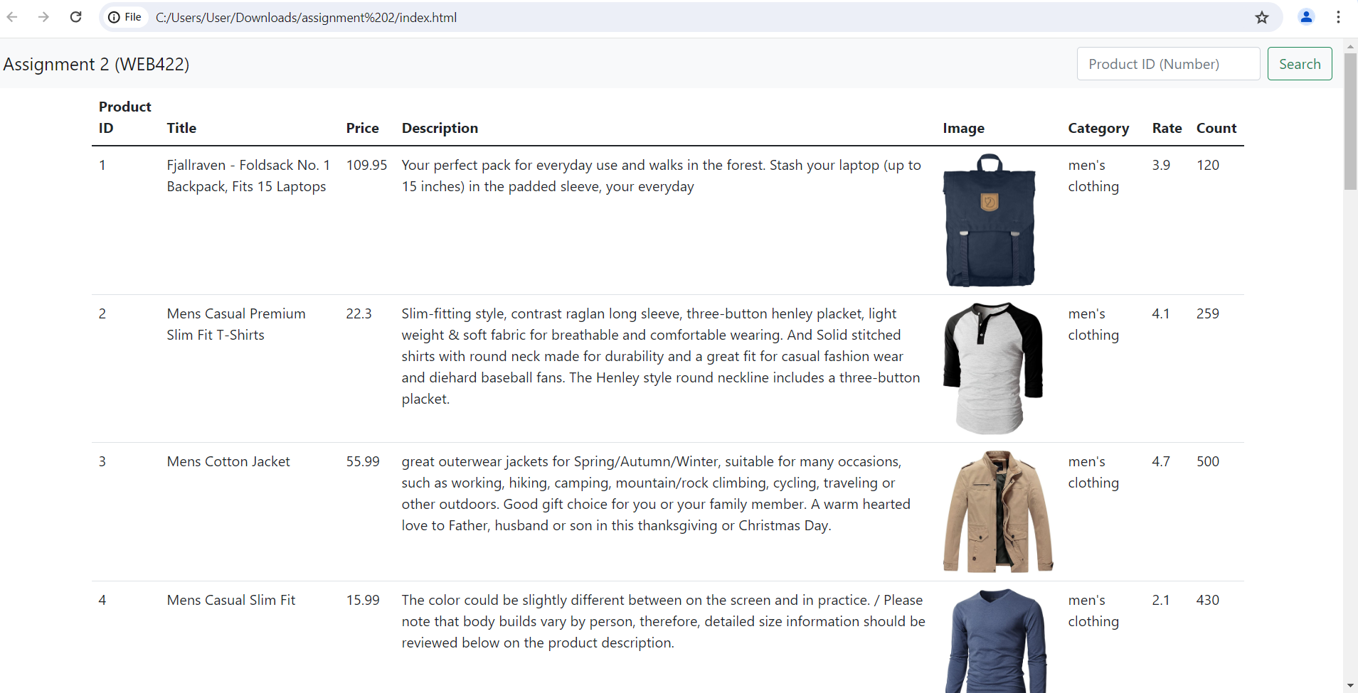

1. Create a modal window toshow a specific product as well as the related fields/features. This window will be shown once a user clicks on a specific row of the table to obtain additional information of the product.

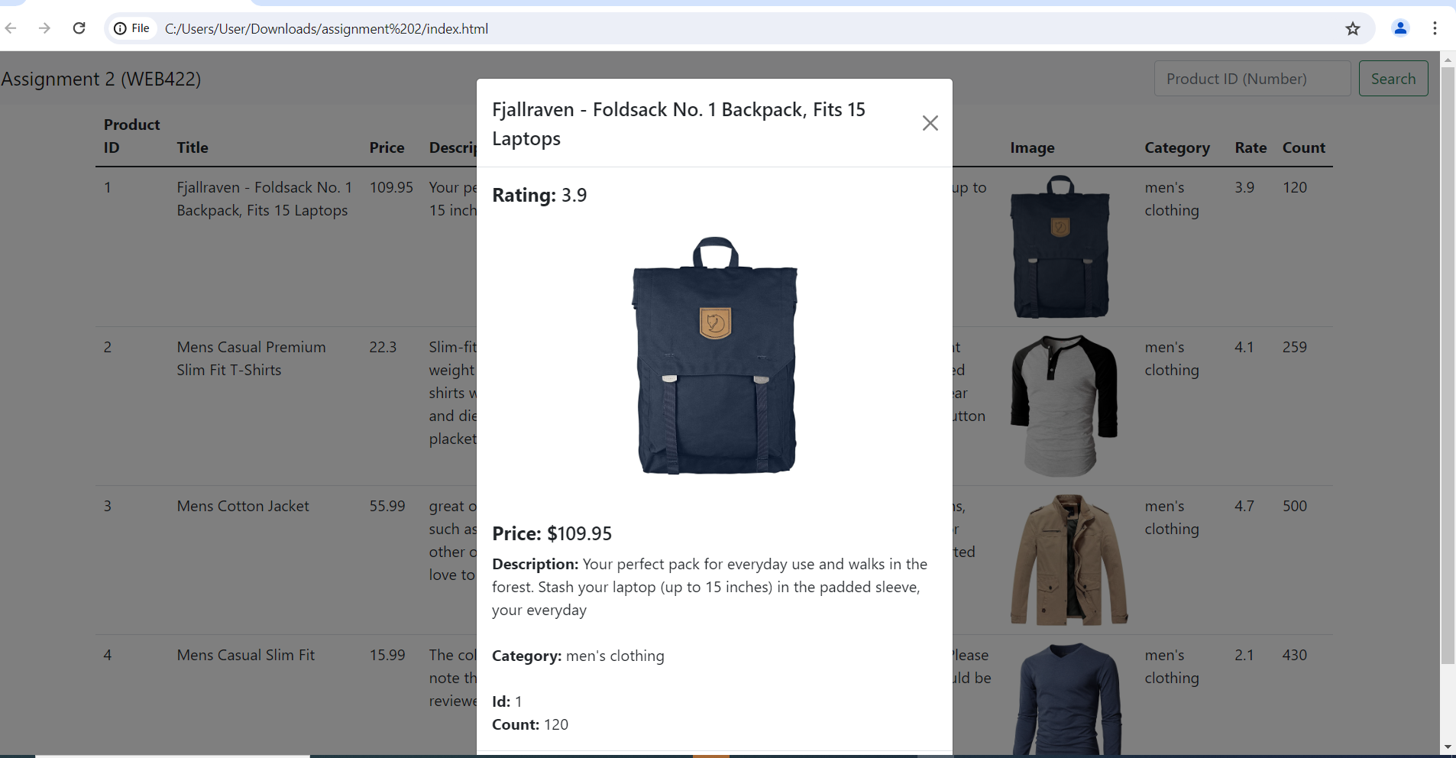

1. Ensure the search bar on the nav bar is functional.

NOTE: You can also work on using the movie API as follows:

OR

### <https://freetestapi.com/api/v1/movies>

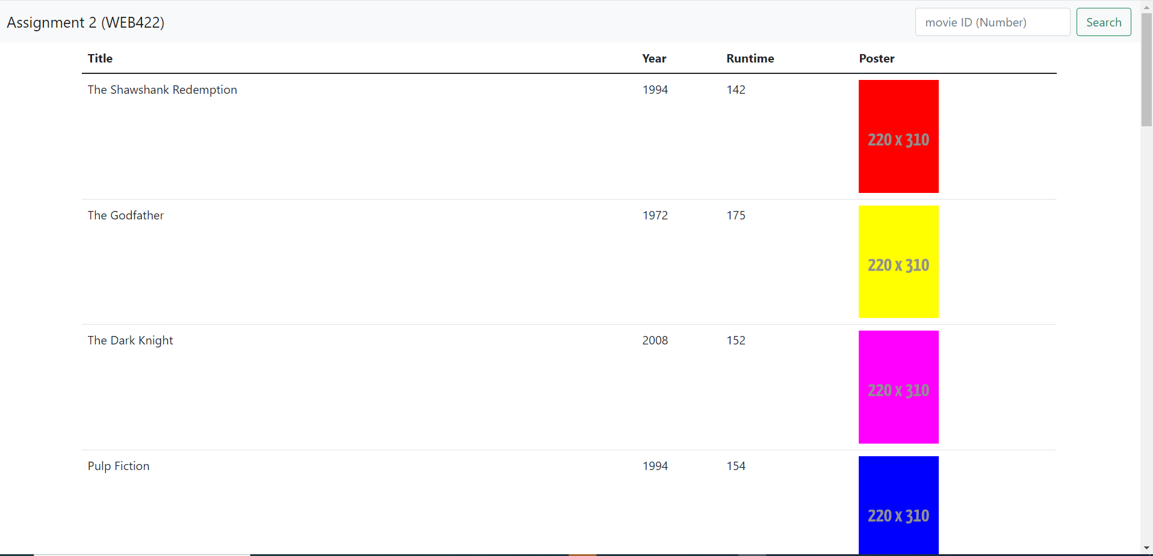

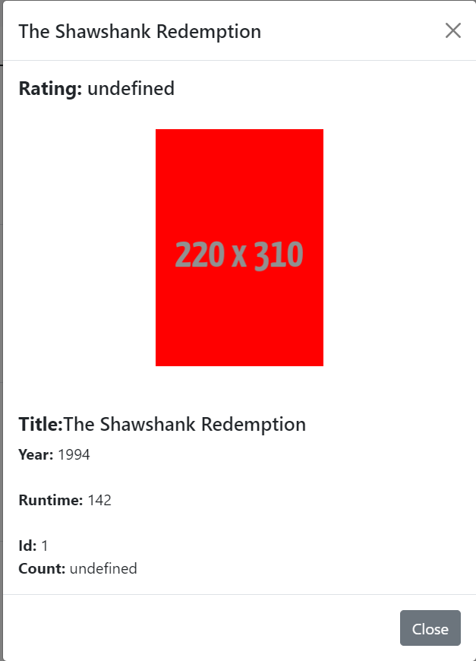

Ensure to fetch the images as well.